Wired by ANDRO Florian
Developed by BOUTON Guillaume
Packaged by SOR Jason
Voice Controlled Connect 4

(Made by students in international stream)

SUMMARY

- SUMMARY……………………………………………………………………………….P1
- Introduction…………………………………………………………………………….P2
- Electronic Part….……………………………………………………………………..P4
- About Arduino Code……………………………………………………………..…P5
- Box…………………………………………………………………………………………P12

Introduction : Bouton Guillaume & Andro Florian only entered in the international branch at the second semester, while Sor Jason was already here at the first semester. The second semester project consisted in a package of improvements to provide to the Connect 4 projet of the first semester that we chosen to take instead of taking another project. So we decided to create a Connect 4 where players could play using their voices thanks to Bluetooh.

Hardware already available :
We had an Arduino UNO Card that was the core of the project. Without it, we would have nothing to supply correctly the others components and nothing to execute the required programs for the good functioning of the project.
42 leds all wired in series but that took the form of a 6*7 grid. All of them had 6 pins :
5V in
5V out
DATA in
DATA out
2 GND
The supply was insured with a charger branched on the 230V and a capacitor between the charger and the first LED. After that, the 5V out of the led was wired on the 5V in of the next led.
The DATA out of the previous led was connected to the DATA in of the next LED, the first DATA in was branched directly on an Arduino Output.
The GND were wired in the same way as the 5V in and 5V out.
A little wooden box to package the grid of leds.
A Bluetooth controller that we already had to replace the 3 microphones of blown control, using phone’s microphones to create a voice control system. It was supplied in 3.3V and worked in serial link with TX (transmit) and RX (receive) pins.
Software already available :
A program that was lighting up one random led each time we transferred it from the computer to the Arduino card.
The Hardware we needed :
We needed and ordered a 128*64 LCD Display to print different information of the occurring and previous game.
The Software to produce :
The Bluetooth controller had to work in serial link with the Arduino UNO Card.

The Wiring and how pins were setted up :
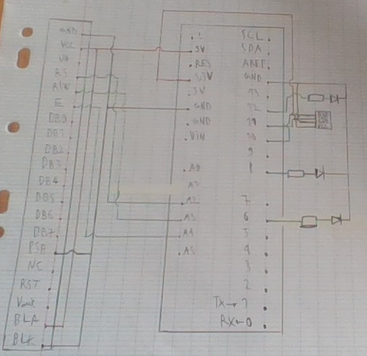
This layout has been drawn early in the project, a bit after receiving components. The Screen wiring had to be changed, but however, we did not succeed to implement it in time. The wiring needed to be reworked and display’s program was severely altering the behavior of the main program.
The 6 was the DATA IN of the first of the 36 leds that were still working (6*6). Since they had an integrated microcontroller each of the could act as a “relay” for the next one.
The pin 11 was set in OUTPUT to transmit data to the Bluetooth.
The pin 10 was set in INPUT to read data from the Bluetooth.
The VCC of the Bluetooth was on 3.3V (the supply it needed)
Pin 8 & 12 were set in OUTPUT and were intended to indicate who it was to play.

Before starting the improvement of the project, we had to figure out how both the electronic and informatic was working or not and the reasons behind that.

ELECTRONIC PART :
The wiring of the grid of leds was not difficult to understand, especially with the simple layout drawn by the students in charge of the project before us.
All the leds of the grid were serial wired on the ground and 5V with a charger to branch the 230V.
The DATA IN of the first led was wired on the pin 6 (output) of the Arduino Uno and the DATA OUT of each led was wired on the DATA IN of the next led (except for the last led)
LEDs wired on PIN 8 & 12 (both OUTPUTS) were here to indicate whose turn it was.
During the first phase, we noticed that the last 4 leds weren’t working. We had a lot of trouble to figure out why they didn’t worked properly and why at one point of the project half of the leds were not working after a quick removal of the 4 first dysfunctional leds. Very late in the project after multiple attempts to make them work with program modifications, we concluded that the issue came from the poor quality of the meld, so we decided to remove all the dysfunctional leds, re-meld them and test them one by one with success.

In parallel we worked on the electronic implementation of the Bluetooth module that had to be supplied in 3.3V and was working in “Serial Linkage”. We decided that the Transmission PIN was connected to the PIN 11 (setted as an INPUT) of the ARDUINO and the Receive PIN was connected to the PIN 10 (setted as an OUTPUT) of the Arduino board. It was a quick part to work on, so we could quickly move on the screen.

The screen was a bit more difficult to work on, because we had to choose between a 4 or 8 bits parallel connection or a serial linkage. However, the choice of a serial linkage was quickly done, because it was quick enough for our needs and it permitted us to save some PINs on the Arduino Card and also made us the job easier on the wiring.
For that, we had to set the PSB on “LOW” so we connected it to the GND, along with the GND and the BLK (BLK being the GND or low voltage reference for screen luminosity)
The VCC was connected to the 5V (along with the BLA for full screen luminosity).
The RS was connected to an Arduino Output (preference for Digital Pin instead of Analog) to select if the datas sent by the Arduino is a command (luminosity change for example) or datas to print.
The R/W was connected to an Arduino Output (again a preference for Digital Pin instead of Analog) to set the Display in “read mode” to receive the datas and execute commands sent by the Arduino Card or “write mode” to send datas to the Arduino (example : validate that the command has been correctly executed).
The Enable was connected to an Arduino Output (again a preference for Digital Pin instead of Analog) to synchronize the Display with the Arduino Card and permit the communication between them.

Taken alone, the Display was working as expected but it’s integration to the project was making everything dysfunctional.
However, the Connect 4 was working as expected. The column selection was working well, the coin stacking was also working as expected and the player selection was working perfectly along with the voice control. This mean that despite not having the LCD Display working, we still have a working Voice Controlled Connect 4.

About the code :
The First part of the code consists of defining the differents variables 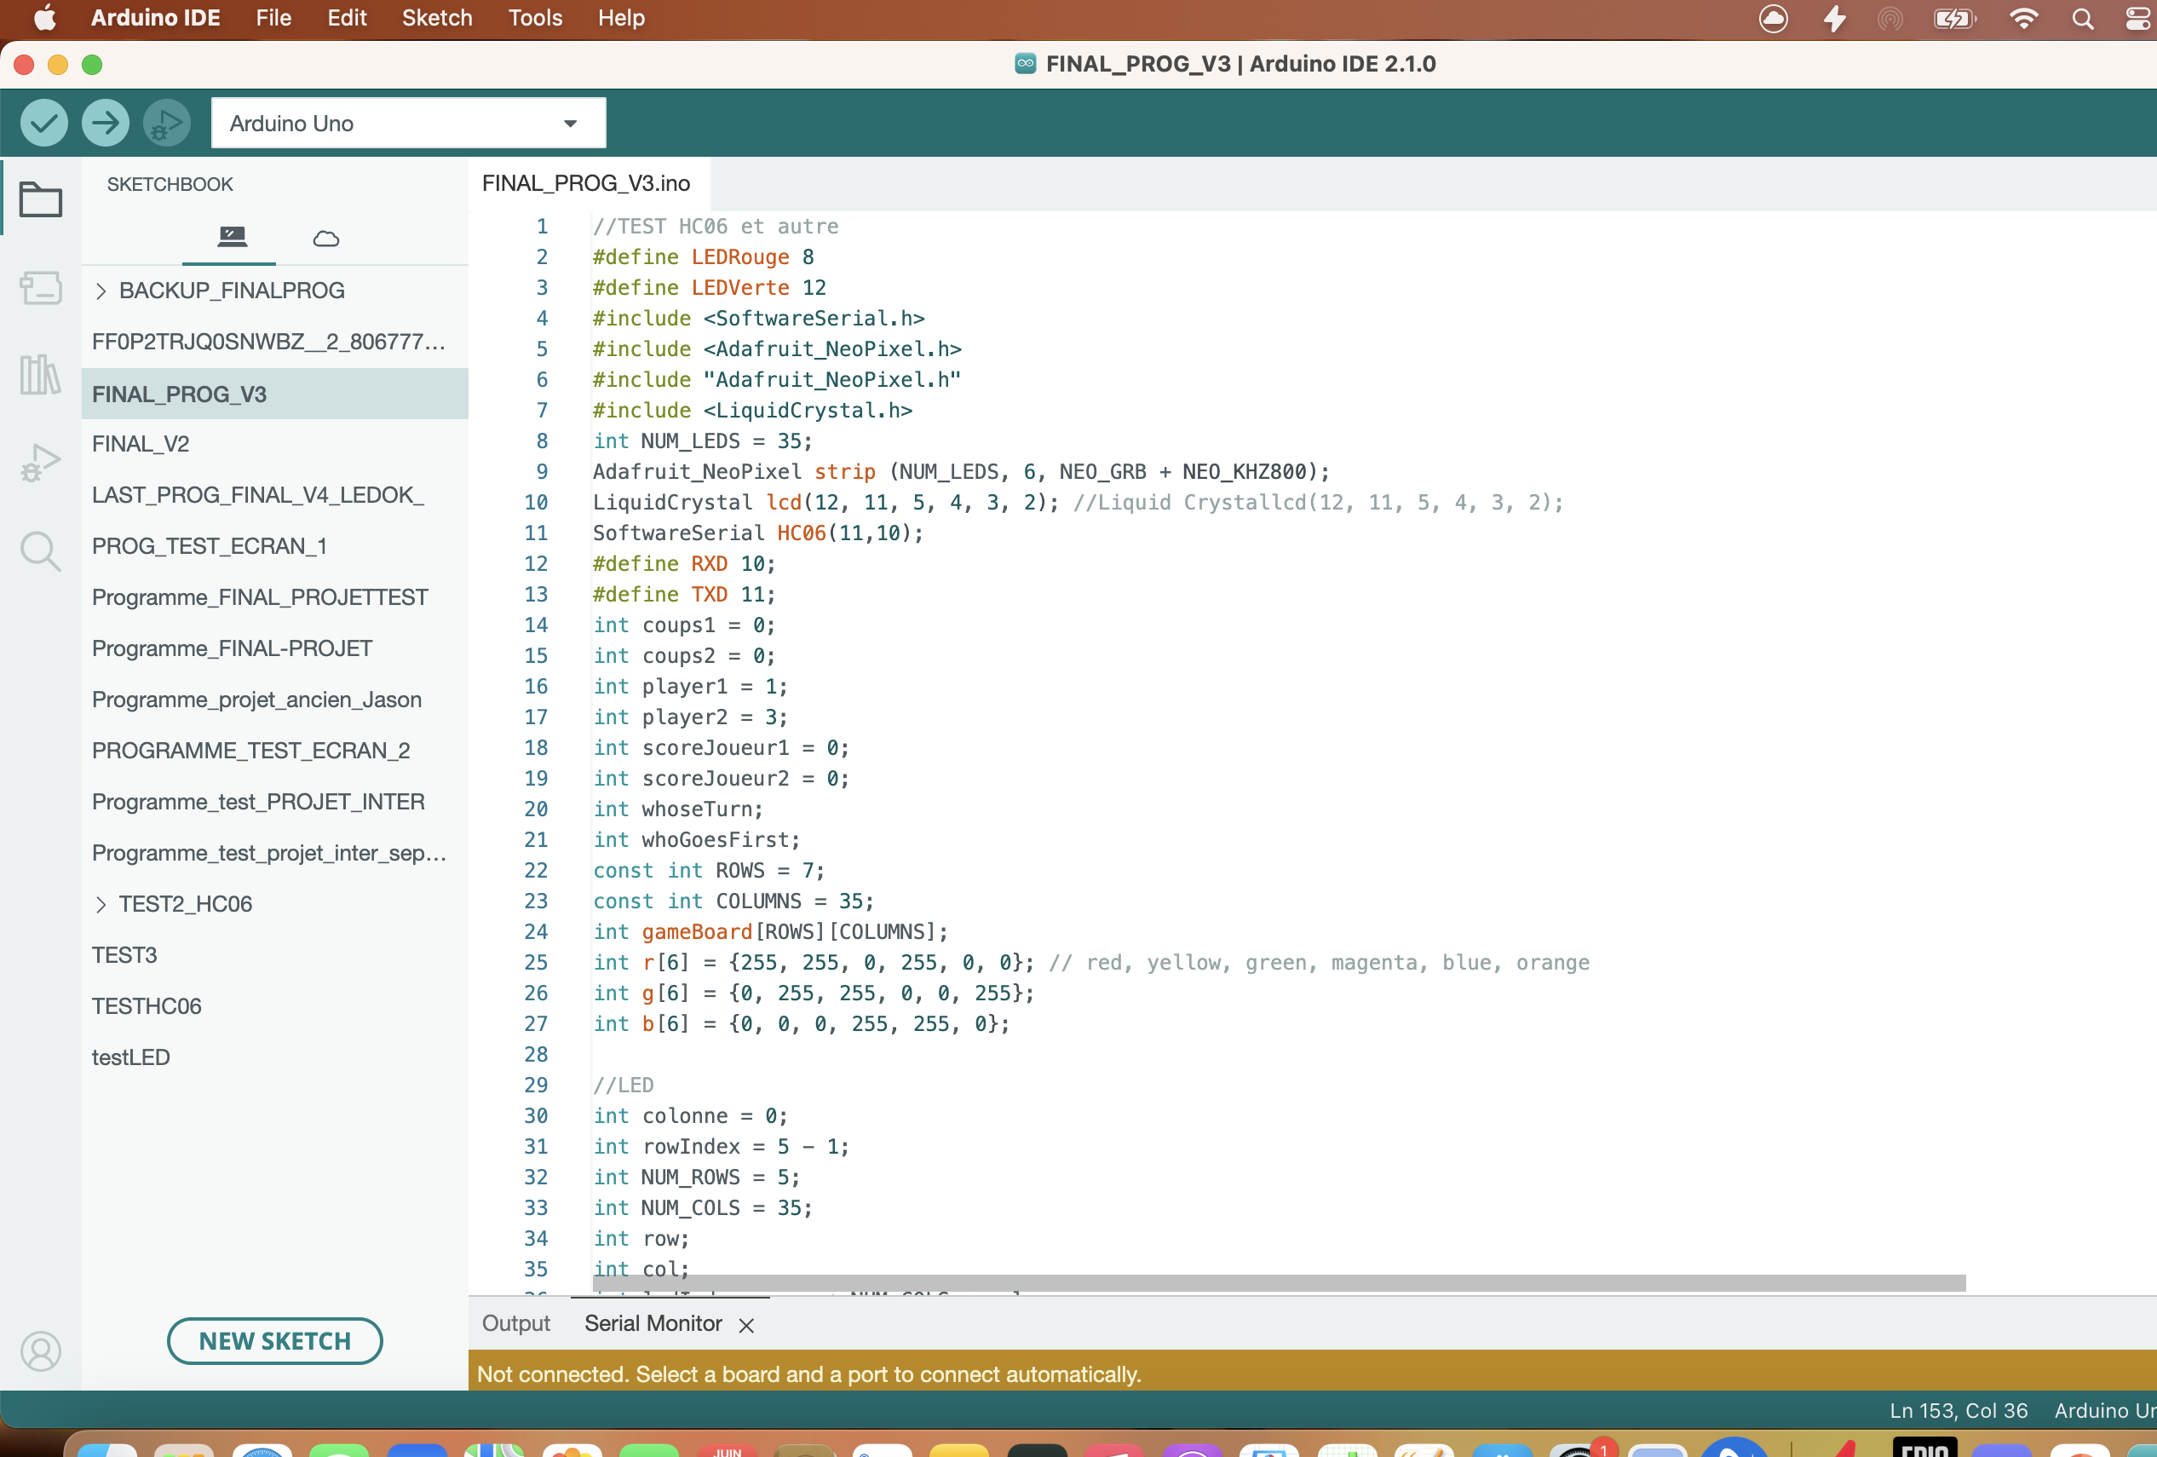
Here we define the differents PIN of the Arduino card RXD of Bluetooth module is on 10 TXD of Bluetooth module is on 11 we have “coups 1” and “coups 2” which are incremental variables permetting us to display on the LCD screen the number of moves played by players
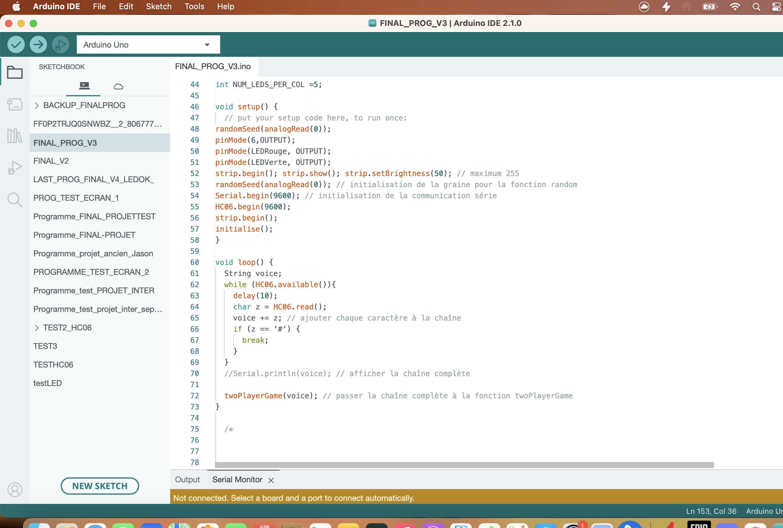
Then we have the Void setup where we find the initialization of the game and the differents mods of communication by using a function (Serial.begin) also Strip.begin initialize the Neo pixel and the created function initialise(); initialize the game by choosing the first player (1 or 2)
Furthermore we can see the void Loop which allow me to call differents functions we verify that the HC06 bluetooth module is available then we read the word character / character
When it’s done we go to twoPlayerGame(voice) which is the function created to play to connect 4.
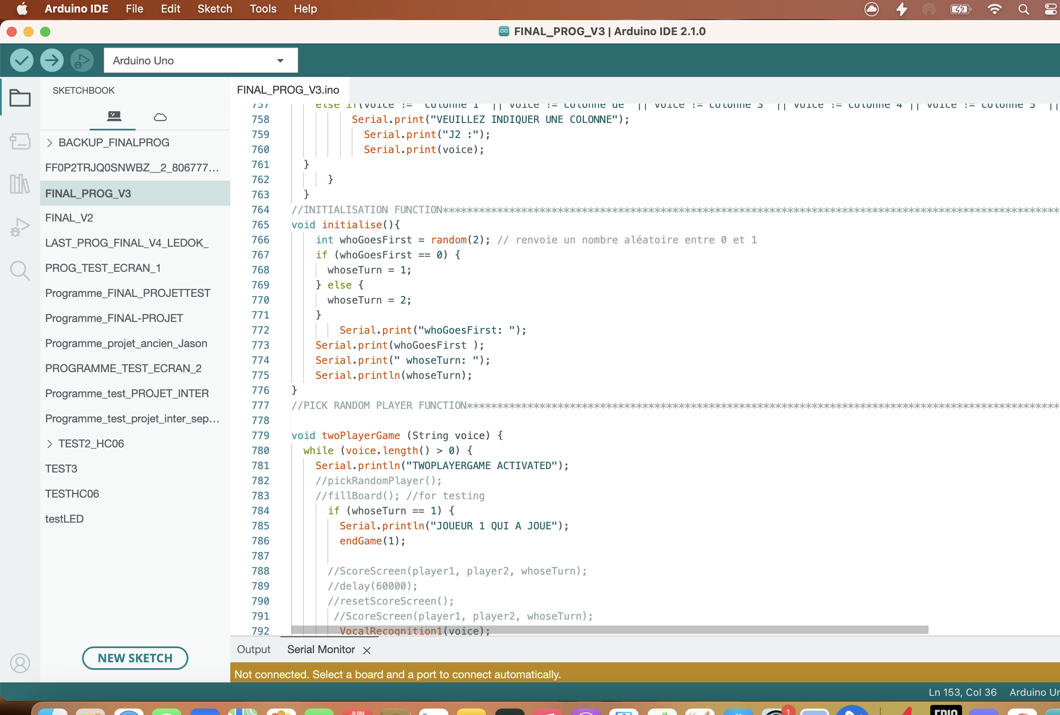
Here the Initialization function this function pick a random number between 0 and 1 and according to it the First player (player 1 or 2 ) will begin the game

The function twoPlayerGame(voice) has in entrance a String which is the word said by the player and received on the Bluetooth module
And according to the number of the player (number 1 or 2) it prints on the serial monitor who player and who will player also It call the function of vocal recognition as you can see on next page, also after the move of the player 1 it automatically change player 1 by player 2 and Inversely.
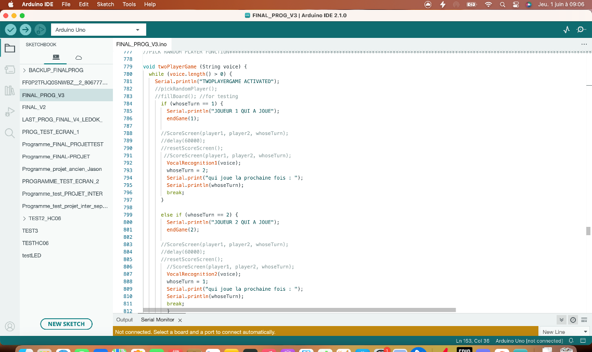
Fast comparison between new function and old one (top and bottom respectively)
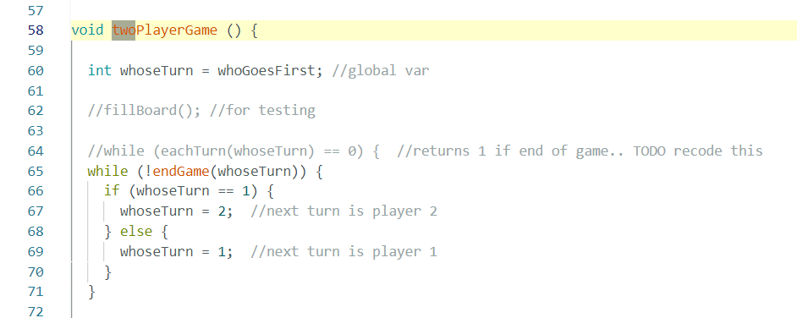
About the Voice Control:
The voice control detection works thanks to the Bluetooth module HC06 when we receive a message it transmit it to the Arduino card which will allow us to recognize the information thanks to two functions composed of some if loops these functions are below :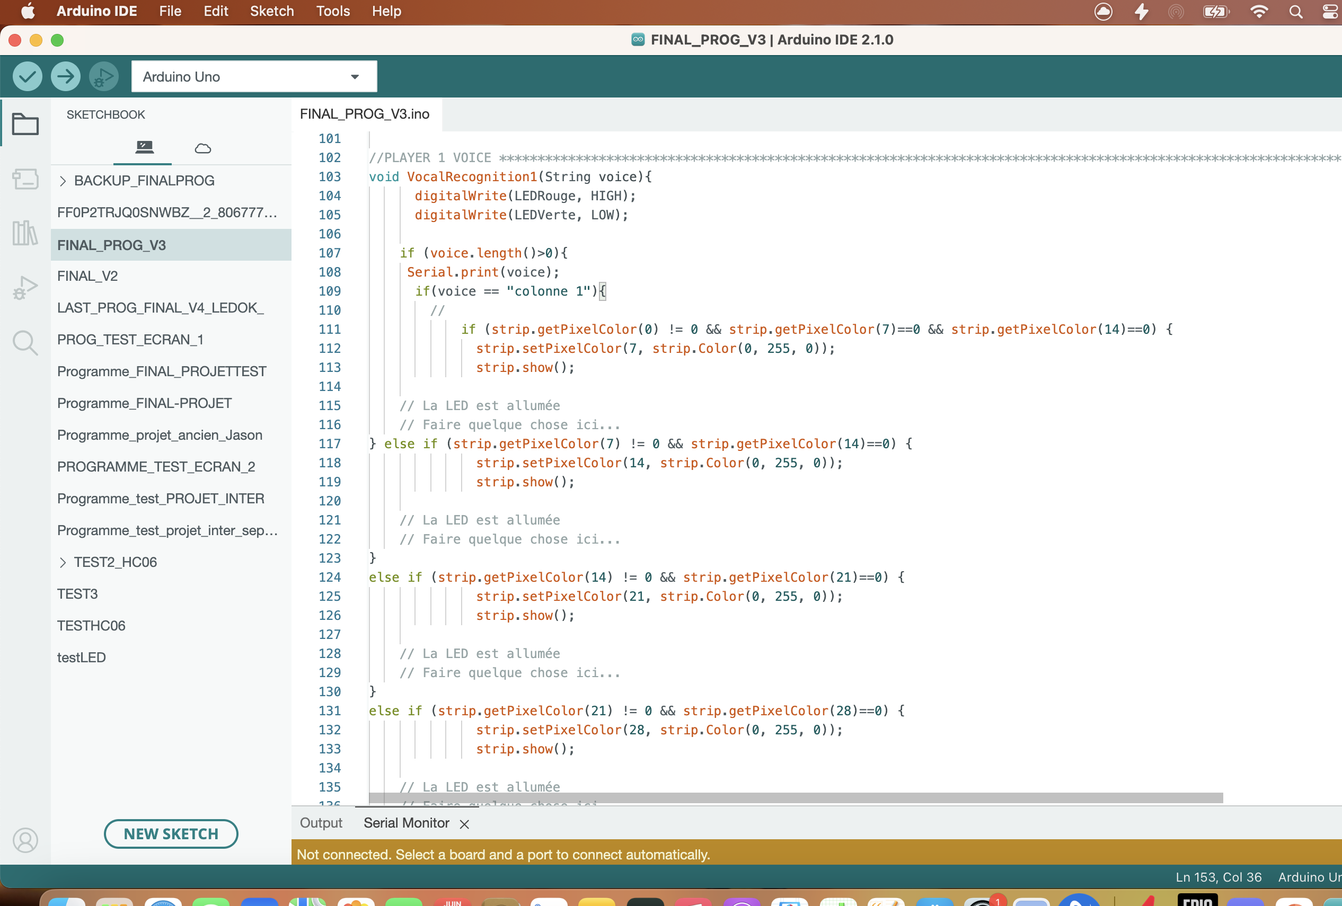
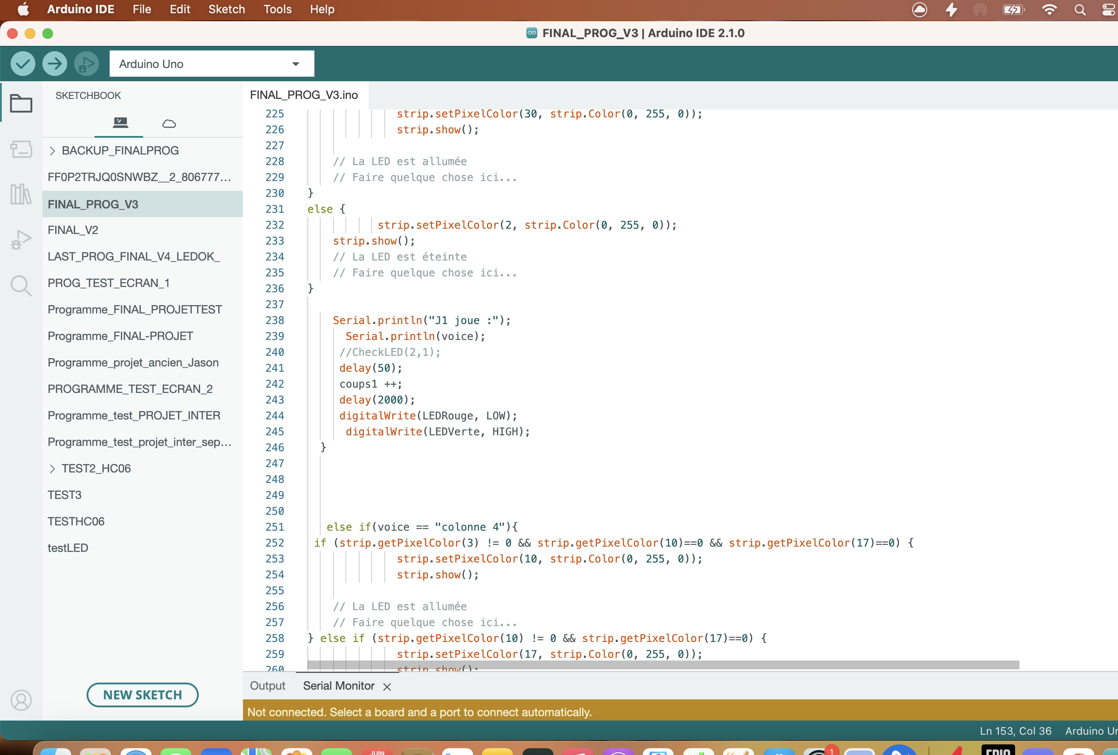
There is voice recognition 1 and 2 according to the number of the player who is currently playing thanks to an application on smartphone called “Arduino Bluetooth Control” developed by broxcode we can send information to the Bluetooth module like “colonne 1”, so Arduino card will recognize it and enter in a if loop that verify by checking the index of the LED if some of them are switch ON or not for example :
We are at column one we verify that the LED 0 is switch off or not is not we switch on this else if the second led index 7 is off and the first one index 0 is on we switch on the led index 7.
If the index 7 is on and index 14 off we switch on this one (index 14) etc…
That’s the same for each column we must verify index by index.
And finally the last if loop is here to threat the differents errors that can occur.
Also the LED are switch on in green or blue thanks to strip.setPixelColor(0,255,0); according to the number of the player (player 1 and player 2)

Problem with EndGame function which must verify the ending conditions of the game 4 LED that are switch on on the same column row or diagonal
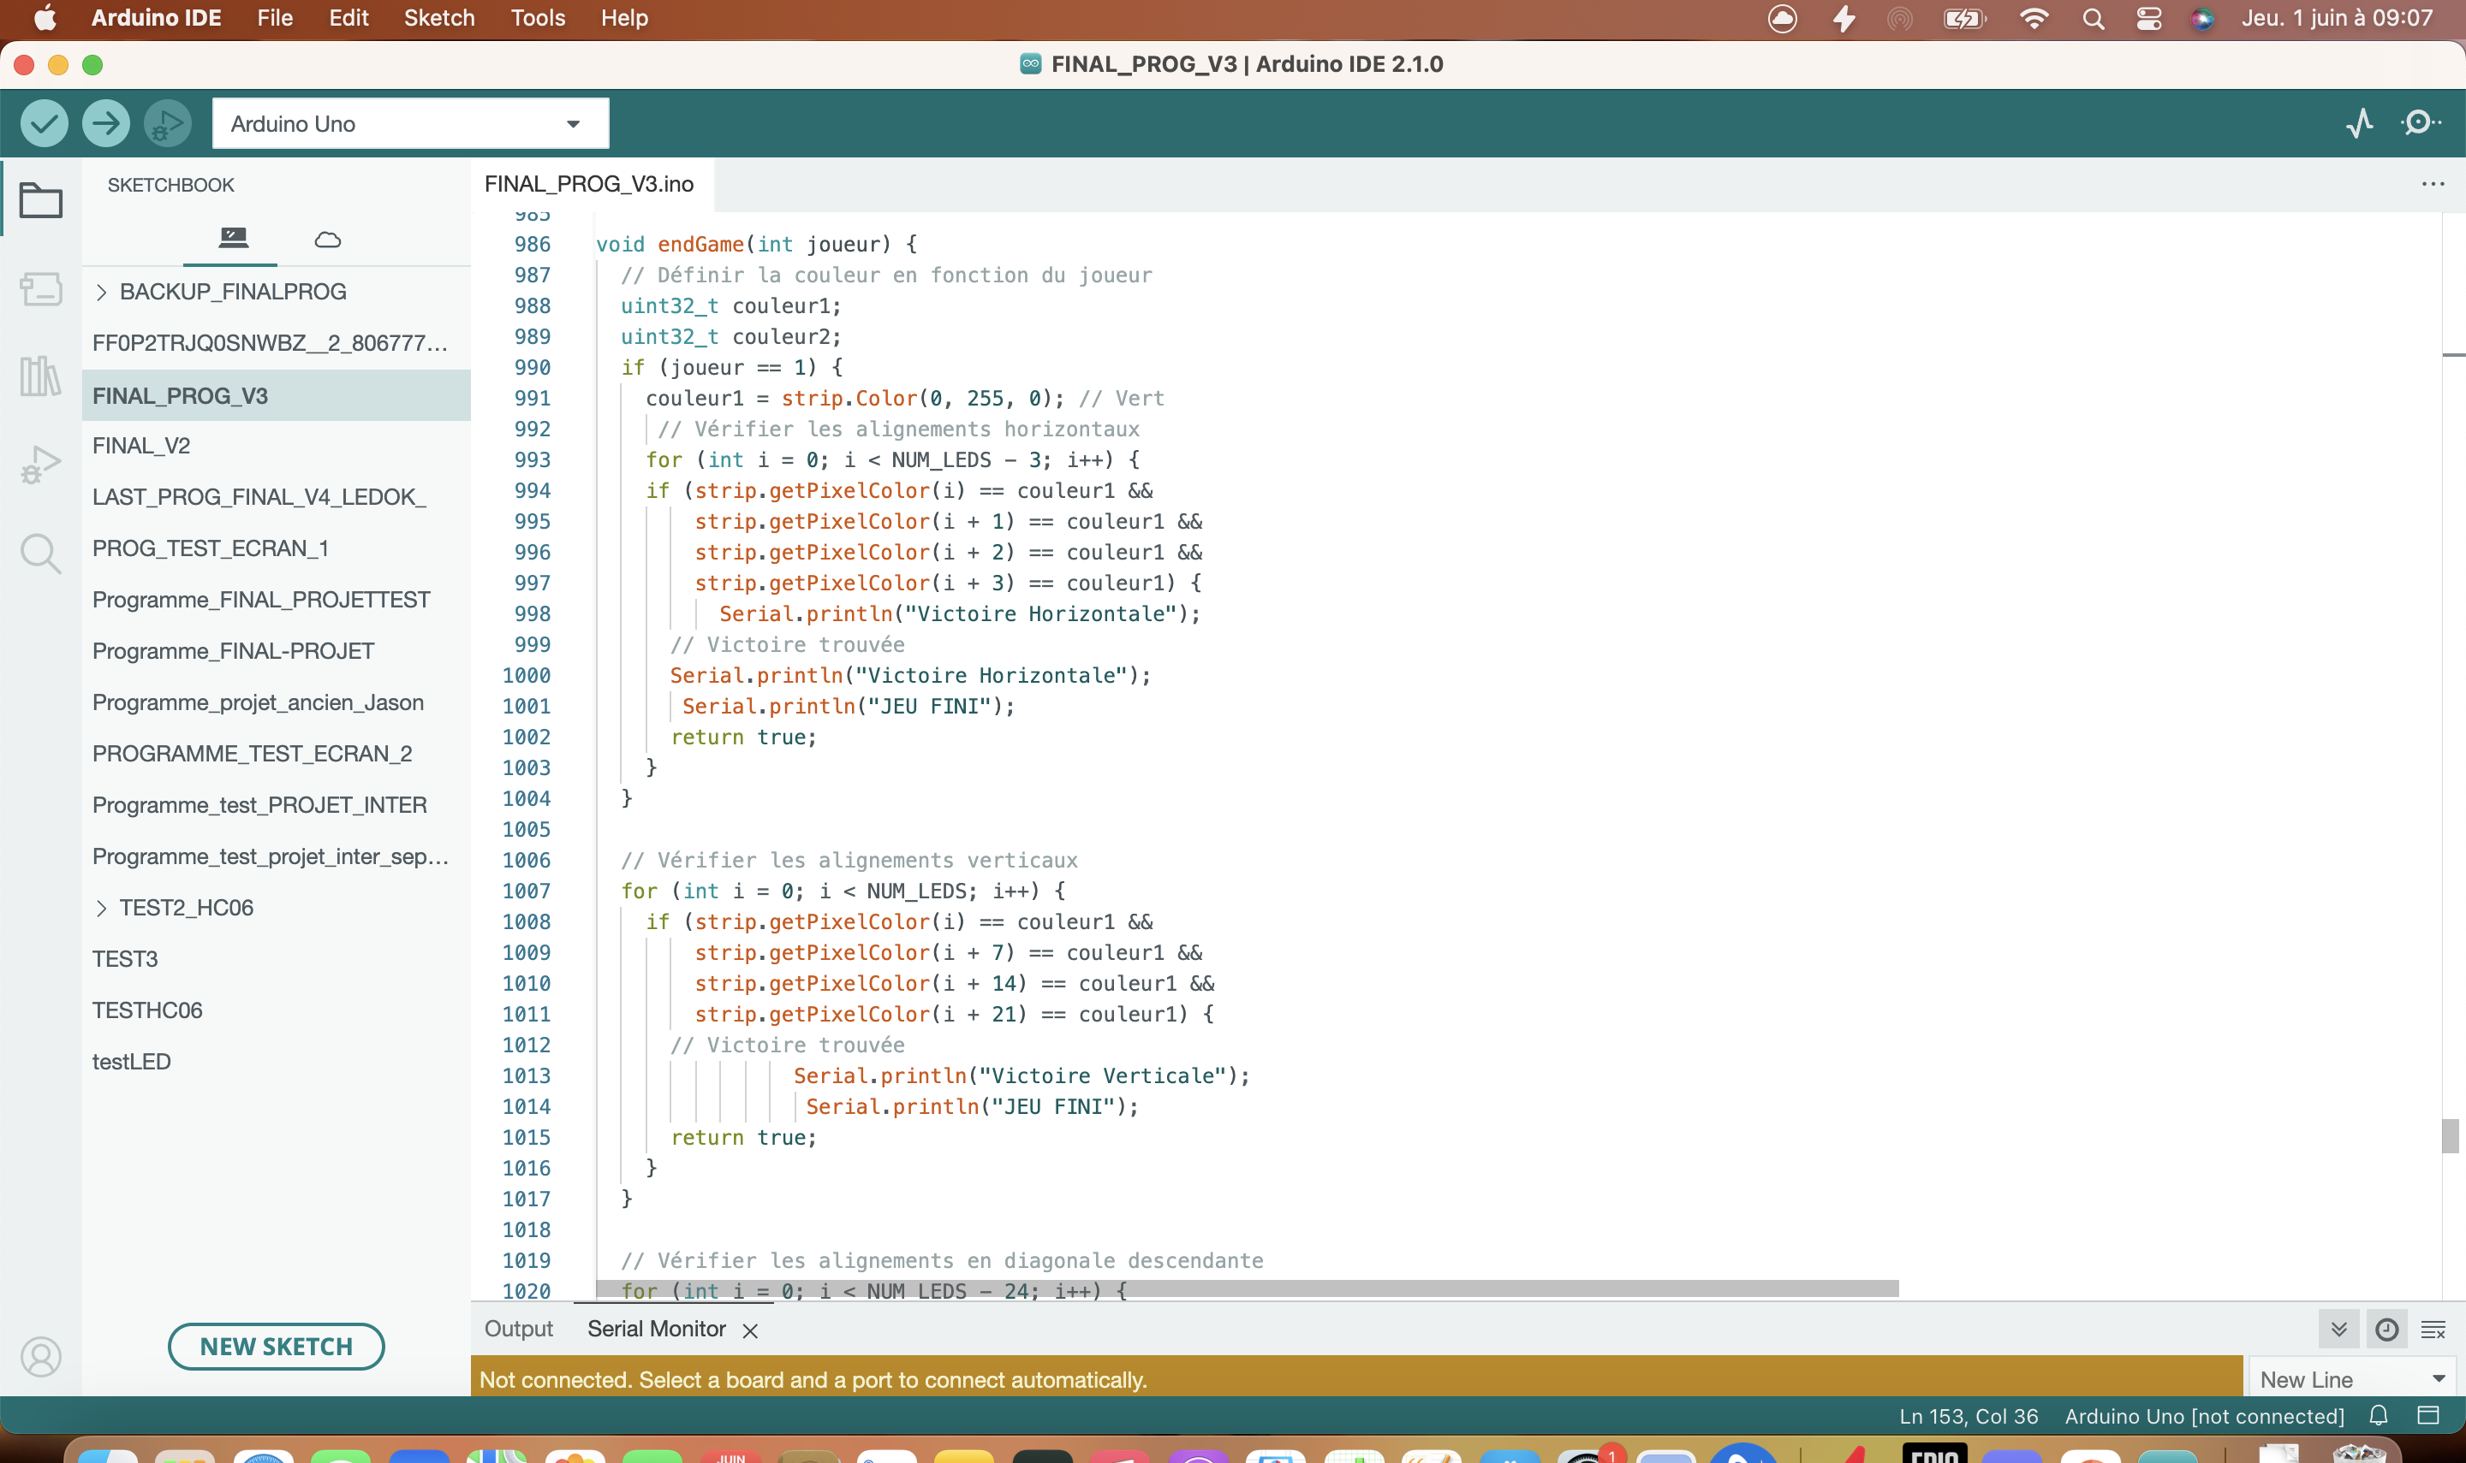
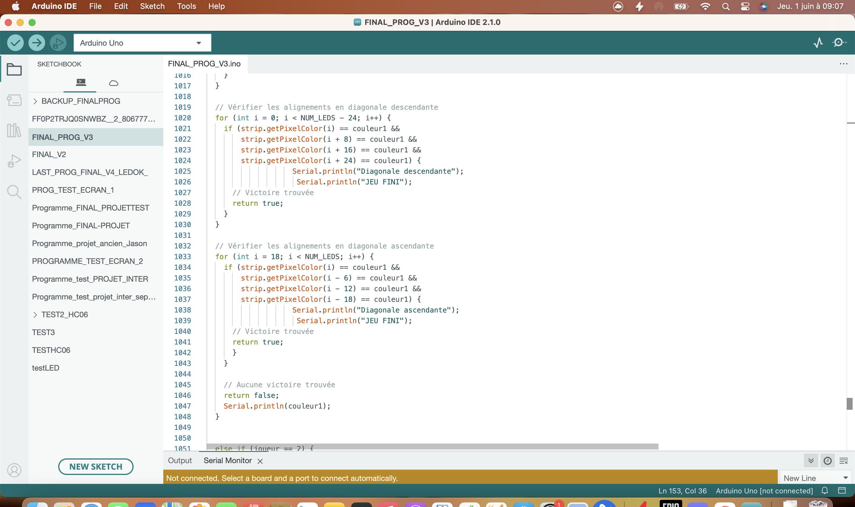
This function didn’t work it check for every index of LED and for each columns, row and diagonal that 4 LED are switched on in the same color.
The issues : the program takes to much time to execute itselves (about 3min)
It does not detect the color because strip.getPixelColor return an int : 255
We use RGB (red, green,blue) colors but if we have (0,255,0) or (0,0,255) it will return 255.
So we can’t use the getPixelColor
Considered solutions :
I tried to use an Arduino two tables to save the move while the player 1 says column 1 for example it will save the number of the player and in an other table it will save the index of the led that has been switch on to try to simplify the manipulation of the datas that are in the table, in fact with Arduino table we have browse the table index by index that’s something that complexify the function EndGame and that’s add more time to execute the program.
(It didn’t work finally)

About the screen :
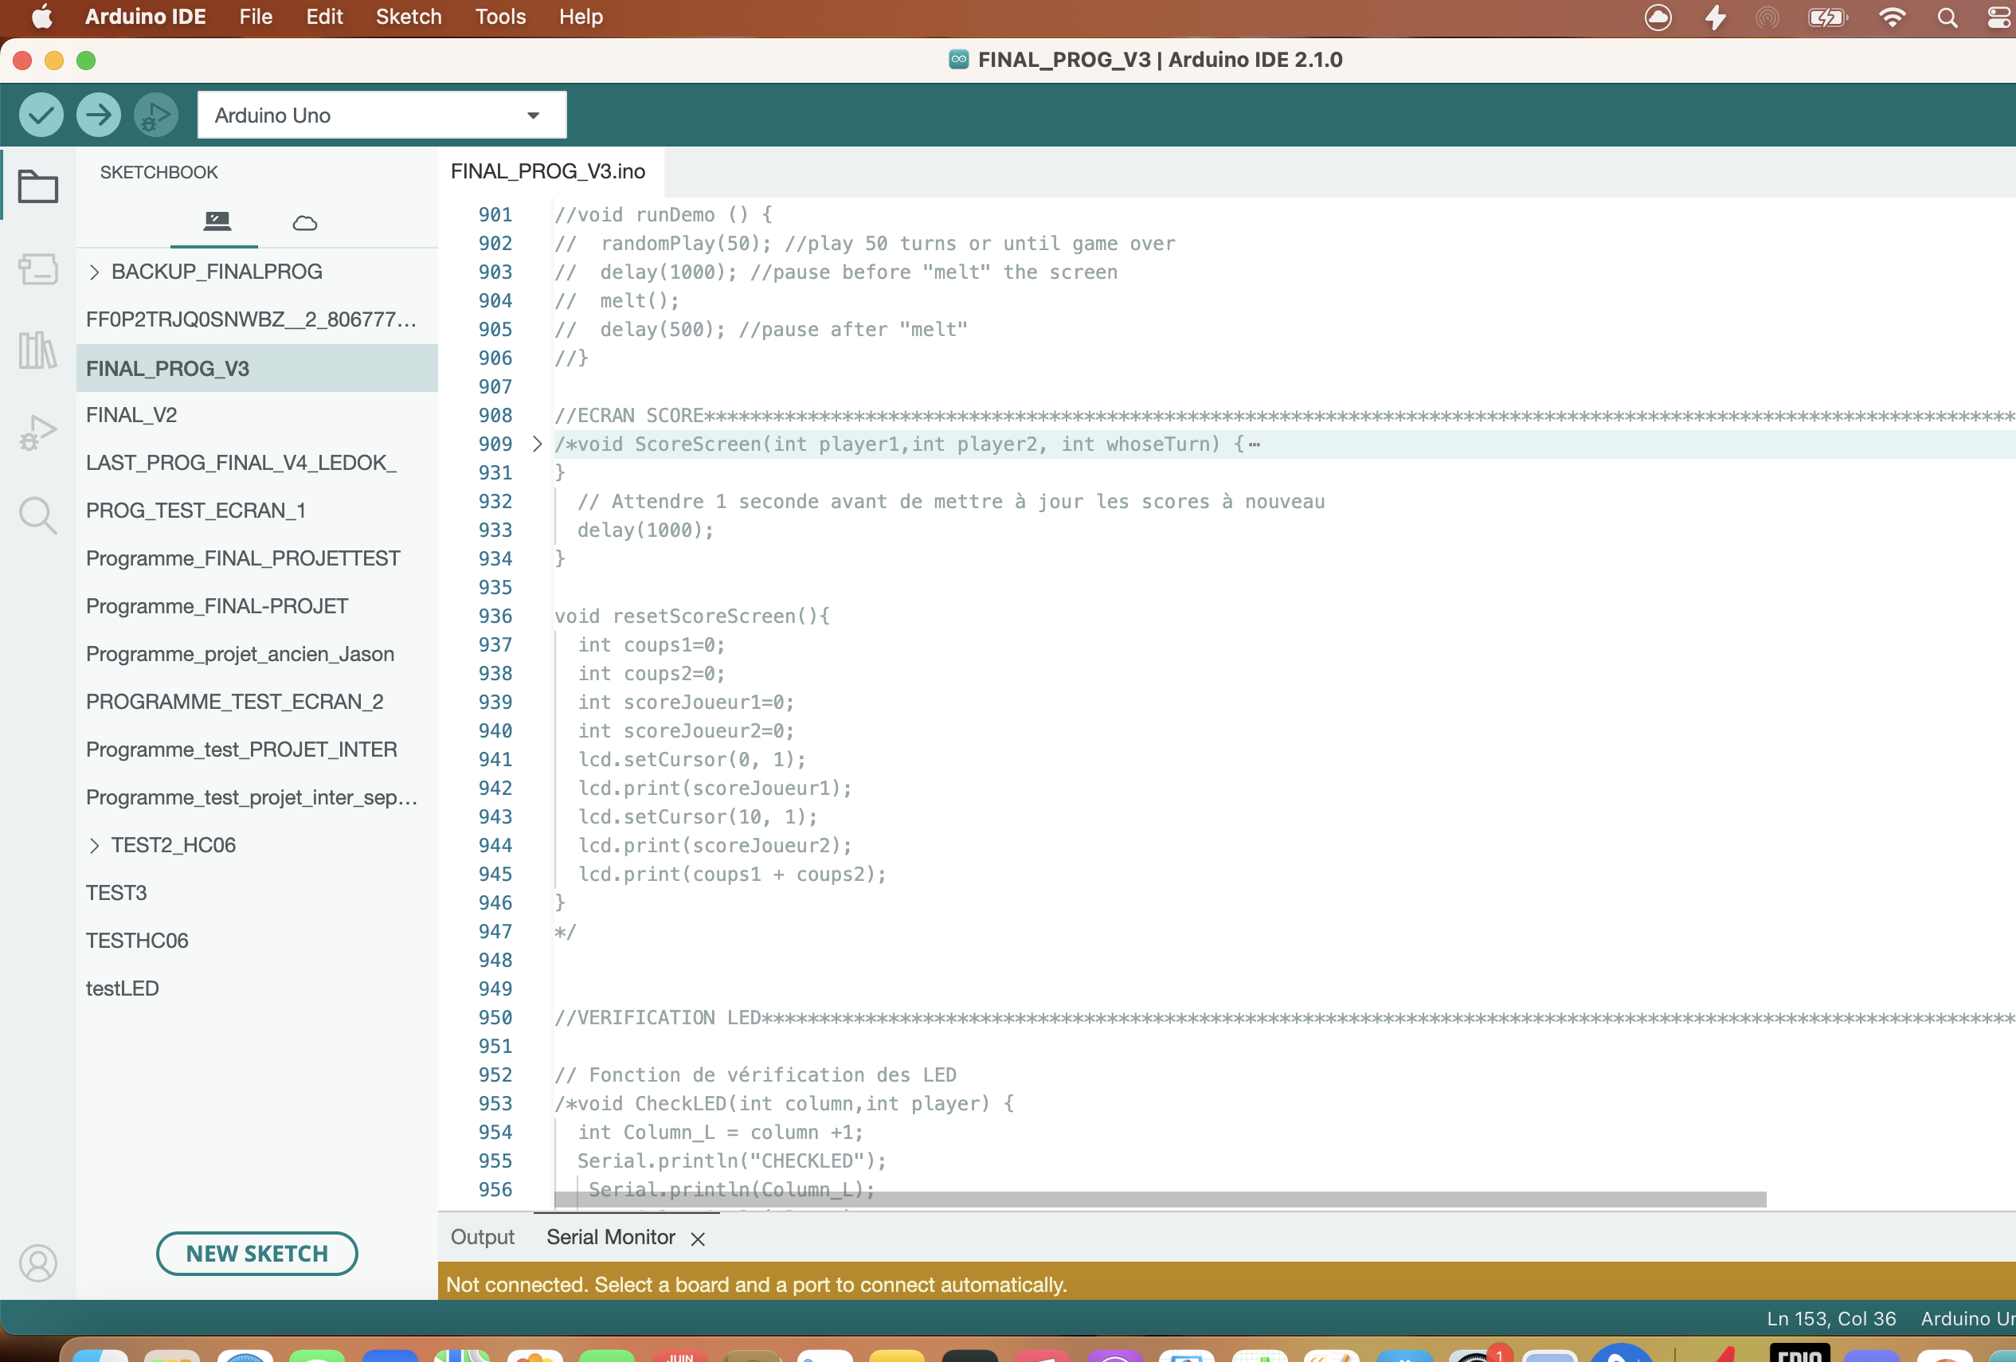
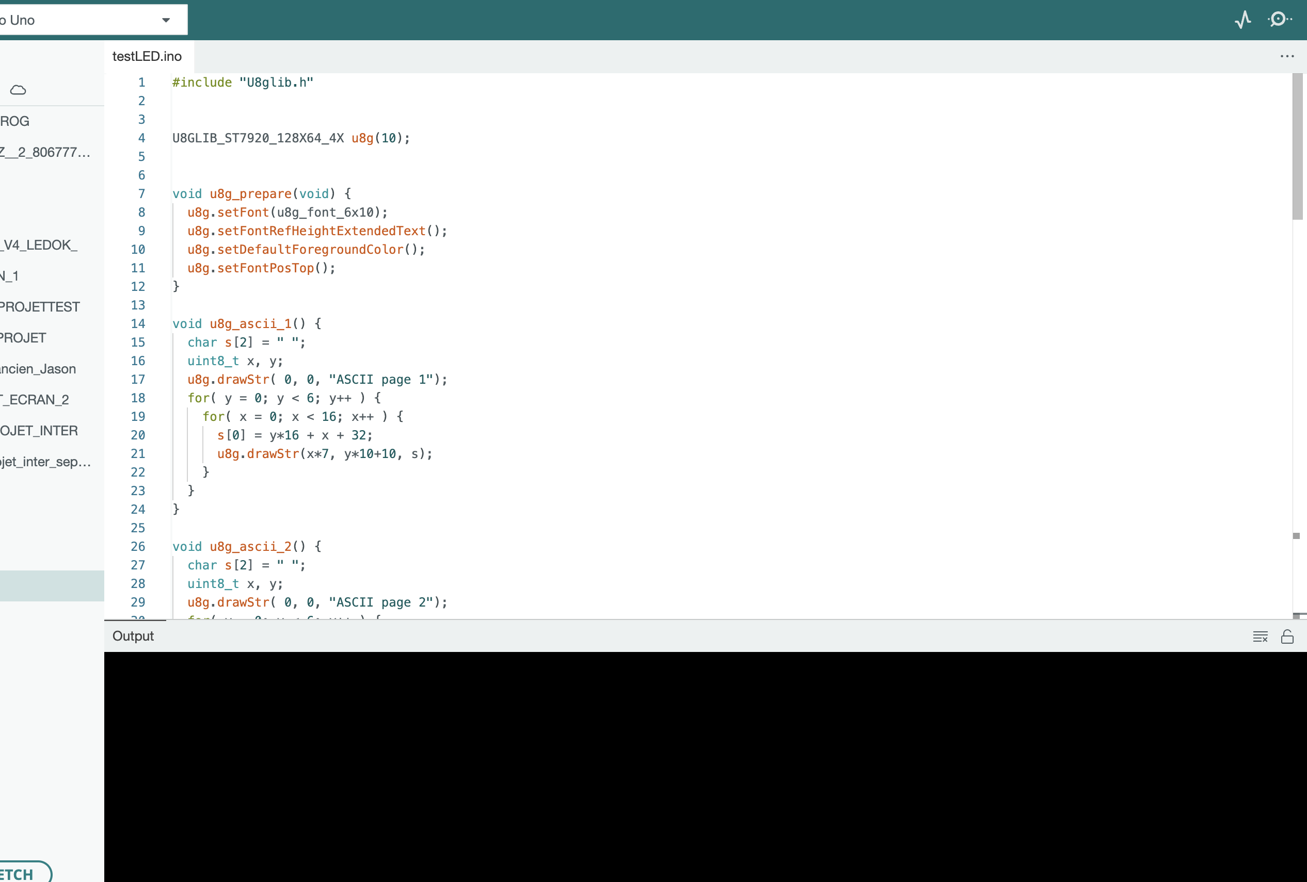
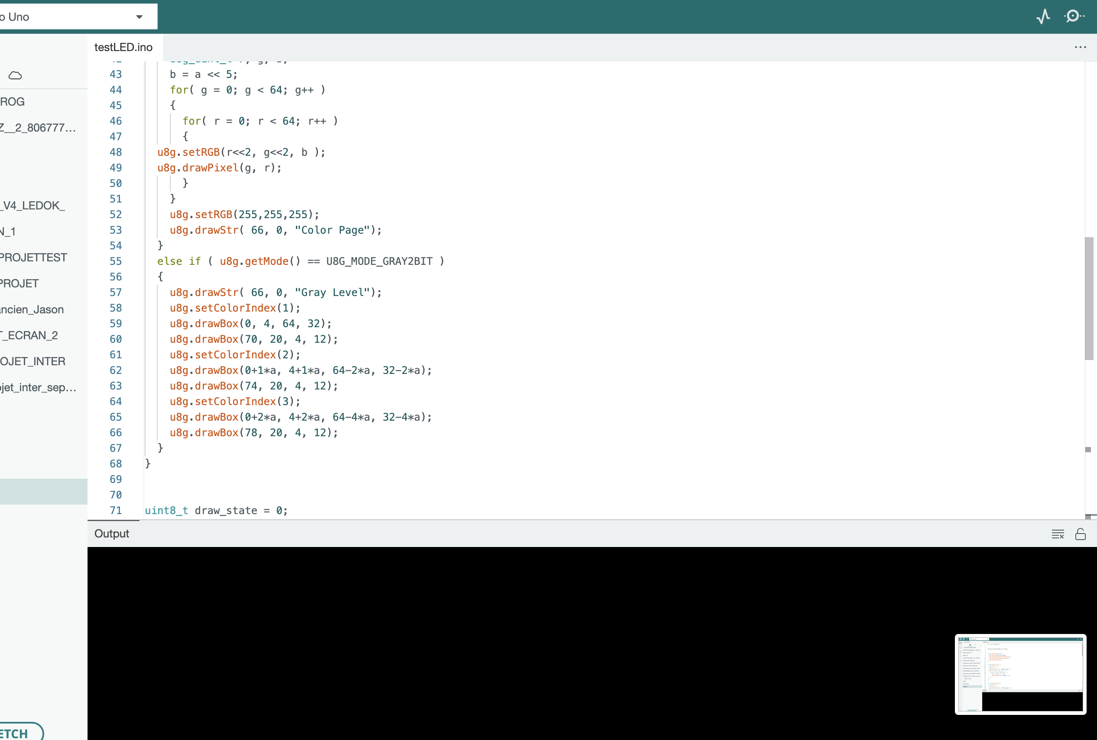
The screen didn’t work properly when I tried to integrate the program into the main one by using the ScoreScreen function, we have in entrance the number of the player (1 or 2) and according to it, LCD screen display the score of the player 1 or the player 2 and also the number of hit that both players did during the game and when the game is finished it displays the number of the winner.

Box
In the first semester, a wooden box was built to put the 42 LEDs. We decided to create a second wooden box using a laser cutter to fit the LCD screen. The box is 11.9 cm long, 10.4 cm high and 5 cm deep. Since the LCD screen was 7.7cm wide and 5.2cm high, we decided to make it 8cm wide and 5.5cm high to make enough place for the screen.
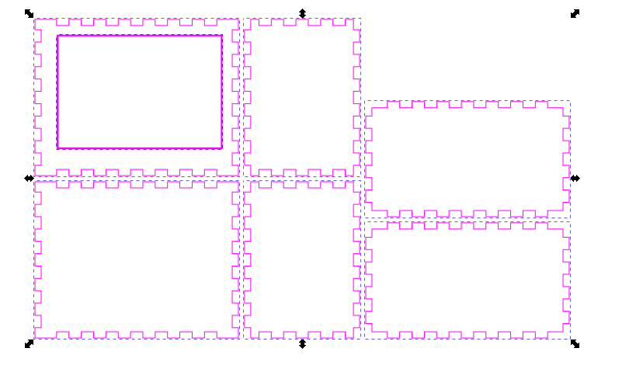
Box diagram
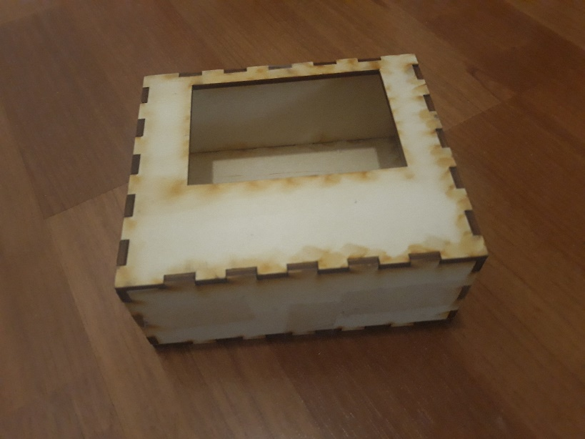
The box

